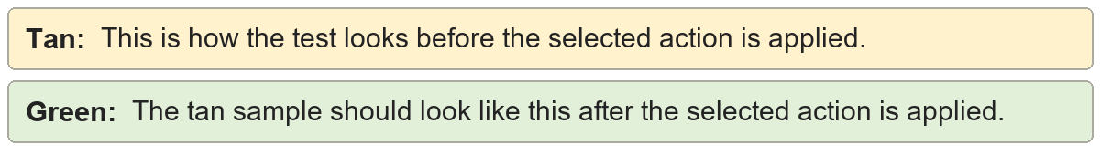
Trailing empty paragraphs | The document ends after this sentence.
Trailing empty paragraphs | The document ends after this sentence.

